Library Management Program Tool

Project User’s Guide

Version 5

**Group 1 [Ursula Richardson, John Kucera, Jason Martin]**

University of Maryland Global Campus

CMSC 495 6380 Current Trends and Projects in Computer Science

Prof. Hung Dao

Revision History

|  |  |  |  |
| --- | --- | --- | --- |
| Revision Number | Date | Description | Author |
| 1 | 24 Feb 2022 | Creation and formatting of this document. Drafted the system requirements and Installation section. Outlined the Operation section. | John Kucera |
| 2 | 24 Feb 2022 | Added descriptions for each menu, Added Subsystem Info section, Added Troubleshooting section, Added NetBeans and Database Installation/Connection sections. | Jason Martin |
| 3 | 3 March 2022 | Revised Installation section to include all steps for installing JDK, NetBeans, and MySQL Server. Revised Operations section with updated wording. | John Kucera |
| 4 | 4 March 2022 | Inserted screenshots for installation steps. | John Kucera |
| 5 | 5 March 2022 | Inserted screenshots for operation steps. | John Kucera |

**USER’S GUIDE**for Library Management Program **(Abbreviated to LMP)**

**System Requirements for Deploying Software**

**Hardware Requirements:**

* Intel Core 2 Quad 1.8 GHz (minimum)
* 2 Gigabytes Memory (minimum)
* Hard disk with at least 3.5 GB remaining space

**Software Requirements:**

* Windows 10
* NetBeans 10.0, or later release
* Java JDK 11, or later release
* MySQL Server 8.0, or later release
* WinRAR

**Installation:**

**(Software Requirement) NetBeans Installation**:

NetBeans is an Integrated Development Environment (IDE) used in the development of software applications. To run the LMP, you must have NetBeans installed.

* Download Link: <https://netbeans.apache.org/download/index.html>
* Installation Instructions: <https://www.geeksforgeeks.org/how-to-install-netbeans-java-ide-on-windows/>

**(Software Requirement) JDK Installation**:

The Java Development Kit (JDK) is a distribution that provides the Standard Edition of the Java Application Programming Interface. To run the LMP, you must have JDK 11 (or later release) installed.

* Download Link: <https://www.oracle.com/java/technologies/downloads/>
* Enable JDK in NetBeans: <https://netbeans.apache.org/kb/docs/java/javase-jdk8.html>

**(Software Requirement) MySQL Server Installation:**

The LMP makes use of a MySQL database to store the Users Table, Books Table, and Checked-Books Table. To create and access this database, a MySQL server must be installed by the user and linked to NetBeans.

* Download link: <https://dev.mysql.com/downloads/connector/j/>

Note: For the purposes of this program, it is best to keep the download in the default location so that the Driver File will be in “Program Files (x86)”.

* Installation Instructions: <https://netbeans.apache.org/kb/docs/ide/install-and-configure-mysql-server.html>

**Note:** Make sure to choose a password and username that you will remember!

* Steps to link MySQL Server to NetBeans Project:

Navigate to the Services Tab in NetBeans. Right-click “Databases” to bring up drop-down options, then select “New Connection” (See figure below).

In the “New Connection Wizard” dialog, next to the “Driver File(s)” box, click “Add”. Navigate to and add the driver file you downloaded, which is located at **\Program Files (x86)\MySQL\Connector J 8.0\mysql-connector-java-8.0.28.jar** (See figure below). This file is used to connect the NetBeans Project to the database.

In the “New Connection Wizard” dialog, click Next, then verify the following connection settings:

**Host**: localhost

**Port**: 3306

**Database**: mysql

**User Name**: [Your MySQL username]

**Password**: [Your MySQL password]

After your confirmation, click Next, then Next, then Finish.

Under Databases, right click the new connection (titled jdbc:mysql://localhost:3306/mysql?zeroDateTimeBehavior=convertToNull [root on Default schema]) and select “Execute Command” (See figure below).

In the coding panel, type the command “CREATE DATABASE_DB;” (See figure below). Then click “Run SQL” button.

**Project Set-Up**:

1. With a software tool that can manage .zip and .rar files such as WinRAR, unzip our submitted zip file **Library-Management-Program.zip** to acquire the **Library-Management-Program** folder.
2. Open Netbeans and click “Open Project” in the “File” tab. Navigate to and select **Library-Management-Program** folder. This will display the **Library-Management-Program** project in the Projects panel. Right click the **Library-Management-Program** Project and select “Properties” (See figure below).

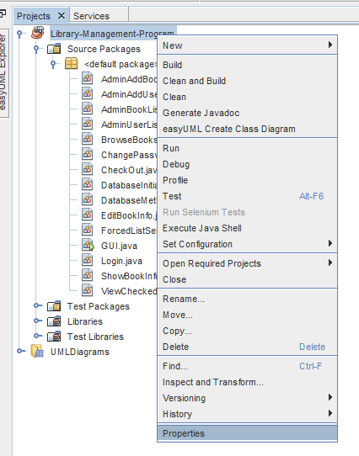

1. In “Properties”, click the “Libraries” Category. In “Libraries”, and in the “Compile-time Libraries” Box, you will see “Modulepath” and “Classpath” labels. Click the “+” button to the right of “Classpath”, then choose “Add JAR/Folder”. Navigate to and select your **mysql-connector-java-8.0.28.jar** file. Back in “Properties”, click the “OK” button (See figure below).

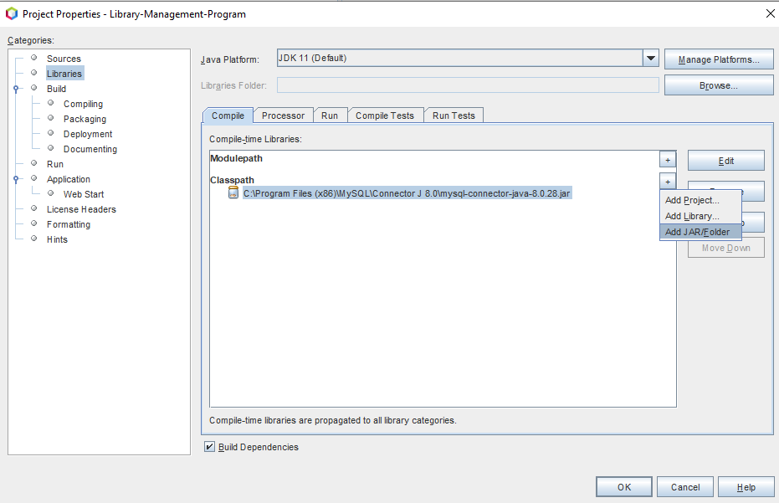

1. In the Projects panel, open **Library-Management-Program > Source Packages > default package** to find the source code files. Click **GUI.java** to open it.  
   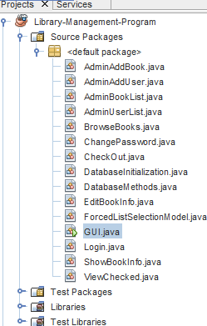
2. The NetBeans project is now fully linked to the MySQL server. Click “Run Project” button. Upon successful compilation, the user will be prompted to provide their MySQL credentials in the Output Console. Enter your MySQL username, and then your Password. They are required to authenticate the connection between the project and the MySQL database.

1. After running the application for the first time, make sure that the Output Console displays the “Verifying Database Status” messages to ensure that the database tables are being properly created (See figure below). Upon database creation, the database is populated with test data.

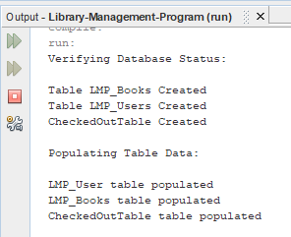

1. Upon successful build and run of the project, the Login Dialog will be the first thing to be displayed. Type in default login credentials (See Login Menu for more information) and click “Log In” button to proceed to the Library Management Program (See figure below).

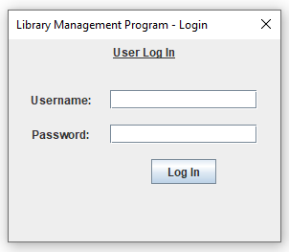

**Standard Operations:**

* **Login Dialog:**

The Login Dialog is displayed upon startup and is used to authenticate the user before allowing them to proceed. In this Dialog, input your username and password. Upon successful authentication, the Login Dialog will close, and the GUI Frame (containing the Menu Bar) will be displayed. For the purposes of this test, use the following pre-set credentials:

Username: **un**

Password: **pw**

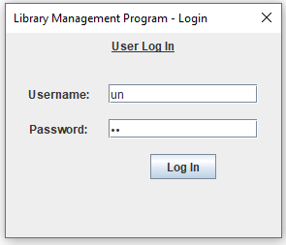

Entering an incorrect username and password combination will result in being denied access. In this case, the Login Dialog will remain displayed and display a message telling the user to try again.

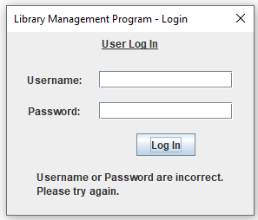

* **GUI Frame + Menu Bar:**

The GUI Frame is displayed after the Login Dialog closes. It is the container of all panels in the LMP. To navigate to these panels, there is a Menu Bar at the top of the Frame containing two Menus: “Main Menu” and “Admin Settings”. Clicking “Main Menu” reveals 4 menu items that lead to their respective panels: “Browse Books”, “View Checked-Out Books”, “Change Password”, and “Log Out”. “Admin Settings” will be detailed later in this User’s Guide.

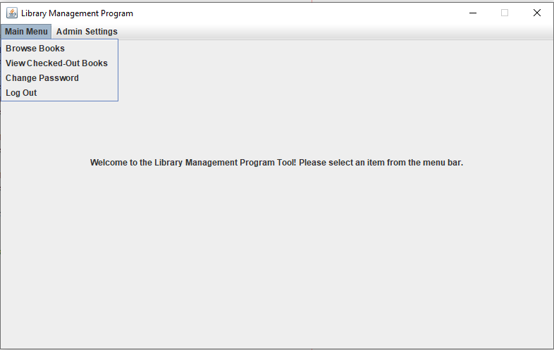

* **Browse Books Panel:**

The “Browse Books” Panel allows a user to search the books stored in the LMP_Books Table of the LMP Database. A user can search by entering desired phrases in the “Title/Author” field, then clicking “Search” button.

Alternatively, if nothing is input, all the books in the database will be displayed in the “Results” table.

Upon selecting a book in the “Results” table, the “Show Book Info” and “Check Out Book” buttons become enabled. Clicking the “Show Book Info” button will cause the Book Info Dialog to be displayed, which shows the following information for the selected book: Title, Author, ISBN, Quantity Total, and Quantity Available.

Upon selecting a book in the “Results” table, users can check out the book by clicking the “Check Out Book” button. This will store the selected book into the user’s Checked-Out Books and display a confirmation message.

If the book is unavailable and cannot be checked out, then a denial message will be displayed instead.

* **View Checked-Out Books Panel:**

The “View Checked-Out Books” Panel will display the user’s checked-out books stored in the CheckedOutTable in the database. Each row will detail the Title, Author, and Check-Out Date of their checked-out books.

Upon selecting a book in the table, the “Return Book” button becomes enabled. Clicking the “Return Book” button will return the book and remove the book from the user’s checked-out books. It will also increment the “Quantity Available” of the book in the LMP_Books Table, which contains the entire inventory.

Upon closing the “Returned Book” dialog, the selected book is no longer present in the table.

* **Change Password Panel:**

The “Change Password” Panel allows users to change their password to a new one of their choosing. There are three password fields for the user to type input in:

* “Current Password”: Input your current working password.
* “New Password”: Input a new password that you want to change to.
* “Confirm New Password”: Enter the same input as “New Password” to confirm the spelling.

Upon entering acceptable input for all fields, the user’s password will be updated in the LMP_Users and a confirmation message is displayed.

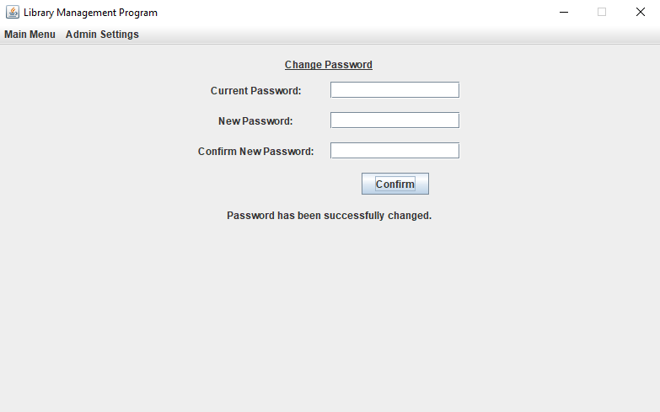

Upon entering an incorrect “Current Password”, a denial message is displayed, notifying the user of the error.

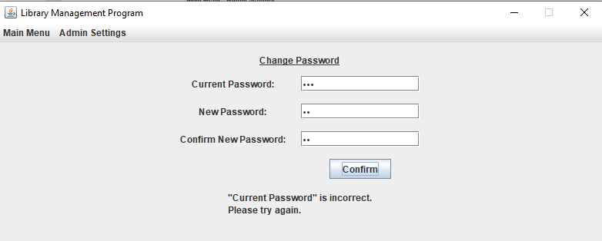

Upon entering mismatched “New Password” and “Confirm New Password”, a denial message is displayed, notifying the user of the error.

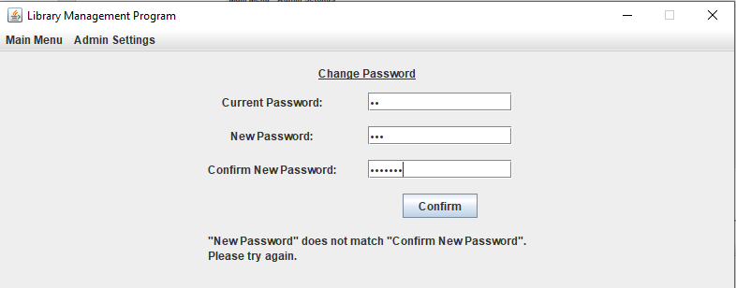

* **Log Out:**

Clicking the “Log Out” menu item will allow a user to log out. This will close the GUI Frame and display the Login Dialog again.



**Admin Operations:**

In the Users Table of the LMP database, users are categorized as either Admin or Non-Admin. When Admins log in and reach the GUI Frame, they have access to an additional menu: “Admin Settings”. The “Admin Settings” menu is not present for non-Admin users. Clicking “Admin Settings” reveals 4 menu items that leads to their respective panels: “List Books”, “Add Book”, “List Users”, and “Add User”.

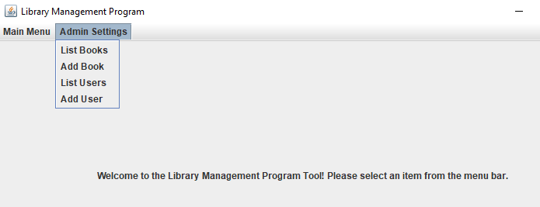

**Note:** Differentiation between Standard Users and Admin Users only occur AFTER login and verification of the user’s admin status. The Login Dialog is the same for both Standard Users and Admin Users.

* **(Admin Settings) List Books Panel:**

The “List Books” Panel displays all the books currently in the LMP_Books table of the LMP database. Upon selecting a book in the table, the “Edit Book Info” and “Remove Book” buttons become enabled.

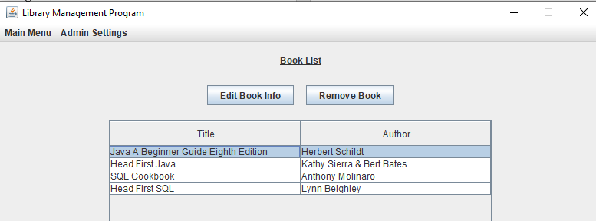

Upon clicking “Edit Book Info” button, a dialog will be displayed that has editable text fields and contains the selected book’s current information. The user can make edits in the fields, then click “Confirm Edits” button in the dialog. A confirmation message will be displayed, and the edits will be stored in the database.

Upon clicking “Remove Book” button, the book will be removed from the database. A removal confirmation message will be displayed.

Upon closing the Removed Book dialog, the selected book is no longer present in the table.

* **(Admin Settings) Add Book Panel:**

The “Add Book” Panel displays a prompt with text fields that correspond to book information and an “Add Book” button. This prompt allows admins to enter information for a new book: Title, Author, ISBN, Quantity (Total), and Quantity (Available). After typing the information, the user can click “Add Book” button to add the book to the database. A book addition confirmation message is displayed.

This book can now be searched for in “Browse Books” Panel.

* **(Admin Settings) List Users Panel:**

The “List Users” Panel displays all the users currently in the LMP_Users table of the LMP database. Upon selecting a user in the table, the “Remove User” button becomes enabled. Upon clicking “Remove User” button, the user will be removed from the database. A removal confirmation message will be displayed. The user will no longer be able to log in with the Login Dialog.

Upon closing the Removed User dialog, the selected user will no longer be present in the table.

* **(Admin Settings) Add User Panel:**

The “Add User” Panel displays a prompt with text fields that correspond to user information and an “Add User” button. This prompt allows admins to enter information for a new user: Username, First Name, Last Name, Password, and Admin Status. After typing the information, the user can click “Add User” button to add the user to the database. A user addition confirmation message is displayed.

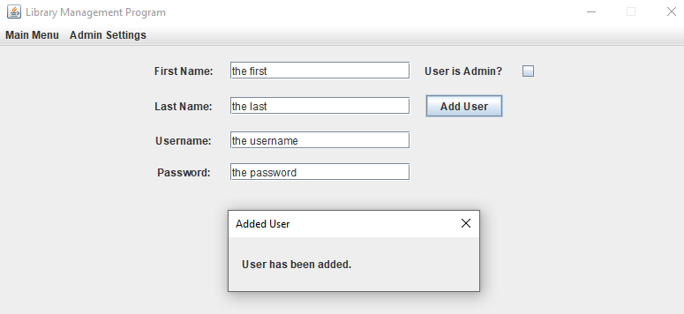

This new user is listed in the List Users Panel now and will be able to log in with the Login Dialog now.

**Library Management Program Tool Database (LMS_DB):**

The Library Management Program Tool uses a MySQL database that contains three tables that are used by the various application menus. The tables are LMP_Books, LMP_Users, and CheckedOutTable. Brief explanations of all three follow below.

* **Books Table (LMP_Books):**

This table holds all the books that are available to users. This table can be viewed by standard users and edited by Admins. It contains the following fields: ISBN, BookName, AmountInStock, AmountOwned, BookAuthor.

* **Users Table (LMP_Users):**

This table holds all the users that have access to the system. This table makes a differentiation between standard users and admins with the use of the field AdminStatus. It also contains the following fields: UserID, UserName, UserPassword, FirstName, LastName.

* **Checked-Books Table (CheckedOutTable):**

This table holds the data for all currently checked out books. It contains the following fields: CheckOutNumber, CheckOutDate, and references the ISBN field from the Book Table and references the UserID field of the User table.

**Troubleshooting:**

**Unable to download or install project and required applications:**

* Ensure that your system meets all hardware requirements. For example, ensure that you have at least 3.5 GB remaining disk space.
* Ensure that you are installing the correct versions of software requirements. For example, ensure that you are installing at least JDK 11 and nothing before that release.

**Unable to login with MySQL credentials at startup**:

* Try using your default “root” account. When installing MySQL, users are prompted to provide a password for the root account. Try to remember it or find where you stored it.

**Unable to login into LMP:**

* Try to use these pre-set usernames and passwords:
* Username: JohnKucera  
  Password: password
* Username: UrsulaRichardson  
  Password: password
* Username: JasonMartin  
  Password: password
* Username: GuestAccount  
  Password: password
* Check that your MySQL username and password have been correctly typed into **GUI.java**. The project may not be properly linked with the MySQL Database.

**Database does not initialize correctly:**

There could be various reasons the database doesn’t initialize correctly when starting the program for the first time.

1. Verify that the correct versions of all software were installed.
2. In “New Connection Wizard”, ensure that the connection settings are all correct.
3. Check that your MySQL username and password have been correctly typed into **GUI.java**. The project may not be properly linked with the MySQL Database.
4. Confirm that the proper MySQL (Connector/J driver) and directory path was selected by the connection and the project.